

**MN507 – Software Engineering**

**Laboratory 8**: System Implementation

**Knowledge Questions:**

1. Discuss the use of throw-away prototype and evolutionary prototype with simple examples.

Ans:

They are commonly used in early phases of design when a large number of ideas are still being considered. Throw-away prototypes may also be used in late stage design in industries in which products are launched at a low state of refinement. You make a prototype, then when you are done with it, you abandon it. For example, you and your colleagues go to lunch, you come up with an idea of the new product. When you discuss the idea, write down the idea and pull out the original design of the paper napkin. When you return to the office, take out the prototype of the paper napkin and transfer it to your computer. You throw out the napkin. In that case, the napkin is considered a thrown away prototype.

In evolutionary prototyping, the concept of the system will be developed as the project progresses. First of all, we will develop the most visual aspect of the system. You present a portion of the system to the customer and continue to develop prototypes based on the feedback received. At some point, you and the customer agree that the prototype is “good enough” and release the prototype as the final product. It is may be best suited for business systems where developers can interact frequently and informally with end users.

**Practical Exercises:**

**You are to draw State Transition Diagrams for the selected software system.**

1. Draw the State Transition Diagram for following scenario:

Company A has a bug tracking system. This system has a UserAccount class which represents a user in the system. Once the System Administrator creates a user, a UserAccount object will be created with a pending state. The UserAccount object will be active only when the System Manager approves the user. If the System Manager rejects the user, the UserAccount will be in inactive state. The System Manager can call Activate User and Deactivate User to move the UserAccount object to active or inactive state. The system administrator will periodically call Delete User function to delete the UserAccount objects, which are in the inactive state.

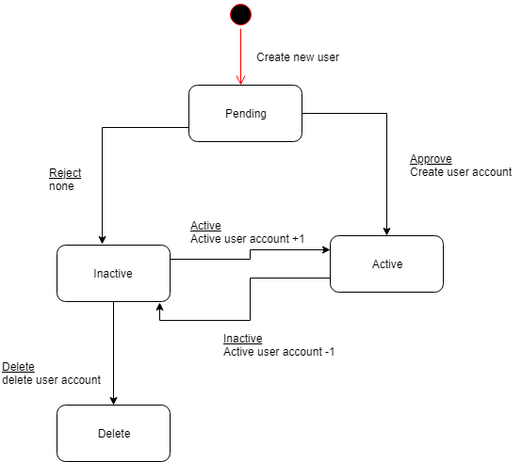

1. Draw the State Transition Diagram for following scenario:

Prospective Students send applications to University. The Unprocessed Applications are taken by the Enrollment Clerk and checked if the students meet the necessary requirements to follow the degree. The applications are then categorized as Rejected Applications and Applications selected for Aptitude Test. The rejected Applications are informed that their applications have been rejected. The students who have been selected for the Aptitude Test are called to sit for this exam.

The result of the students who sit for the Aptitude Test is analyzed. Students passing the test will have their status changed to Call for Interview. Students who have failed and students who haven’t sat for the exam have their applications rejected (Rejected Applicants). Once again both types of students are informed of their Status.

The students who pass the Interview are selected (Selected Applicants). The students who fail the Interview are rejected (Rejected Applicants). Students who are not present for the Interview and are just failing the interview are classified as (Appeal Applicants).

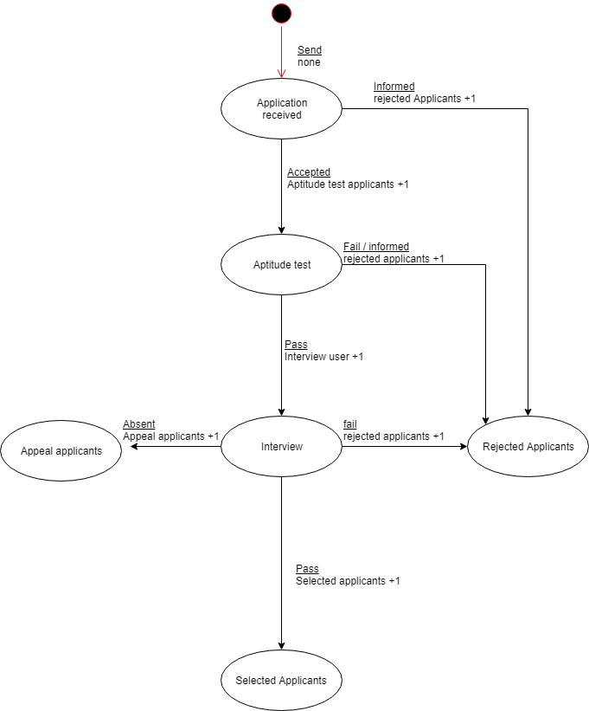

**It is an individual task. Each student is required**

**Github Screenshots:**